Assignment 5 – Programming Part

**Code Location:**

**Question 1**

**b.** Using the Decision Stumps algorithm as a weak learner, and AdaBoost with 100 iterations, we obtain the following graph:

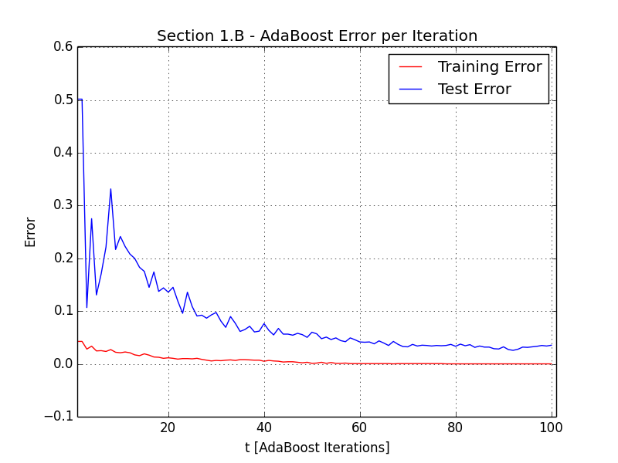

The results are consistent with the theory –



In other words, the training error drops exponentially fast. Indeed, the training error graph shows a steady continuous drop and presents a behavior of a function bounded from above by $e^{-2Tγ^{2}}$.

We also note that the Weak Learner classifier already did a plausible job, and therefore we get a low error of about 5% to begin with (though this doesn’t formally prove that $γ$ is high for this problem set).

Another key observation is that the training error converges to zero after $T=0.5γ^{-2}log⁡(n+1)$ rounds. Taking approximations of $γ=0.3;n=2000$ we get $T=61$ iterations where indeed the training error graph converges to zero.

The test error keeps decreasing even after the training error approaches zero due to margin-based explanations not discussed in the course. Notice the slight increment in test error by around round 95, which can be attributed to AdaBoost overfitting the training data.